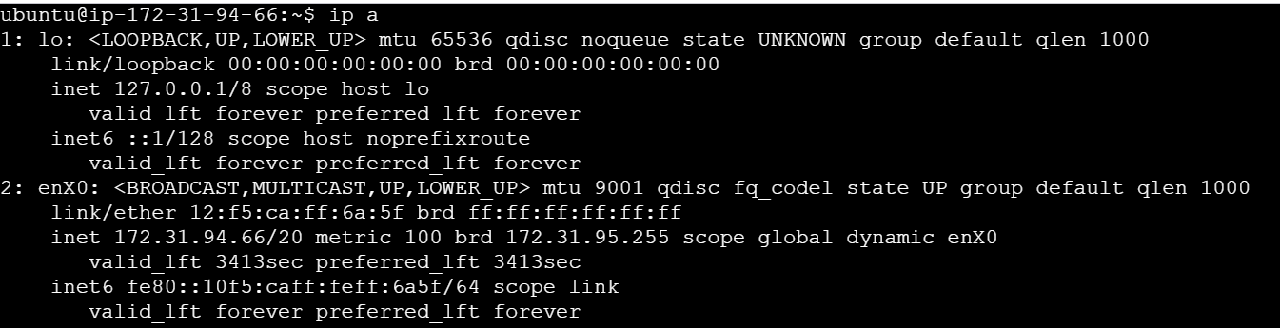

**1. Interface: enX0**

This is the primary network interface (likely a virtual or renamed Ethernet interface).

Flags:

UP, BROADCAST, RUNNING, MULTICAST: Indicates the interface is active and can broadcast and receive multicast packets.

MTU:

Maximum Transmission Unit is 9001 bytes (suggests Jumbo Frames are enabled—common in cloud environments like AWS EC2).

IPv4 address:

inet 172.31.94.66 with netmask 255.255.240.0

This places the machine in a subnet (likely a private IP in a cloud environment like AWS).

Broadcast address is 172.31.95.255.

IPv6 address:

inet6 fe80::10f5:caff:feff:6a5f%enX0 is a link-local IPv6 address (used only for local network segment communication).

MAC address:

ether 12:f5:ca:ff:6a:5f is the hardware address (unique identifier for the NIC).

Traffic stats:

RX (Received):

1346 packets, 687984 bytes (~687.9 KB)

TX (Transmitted):

1173 packets, 159110 bytes (~159.1 KB)

No errors, dropped packets, overruns, collisions — indicating a healthy connection.

**2. Interface: lo**

This is the loopback interface, used for internal communication within the host.

Flags:

UP, LOOPBACK, RUNNING: Interface is operational and only used for internal communication.

MTU:

65536 bytes — typical for loopback.

IPv4 address:

inet 127.0.0.1 with netmask 255.0.0.0 — standard loopback address.

IPv6 address:

::1 — the IPv6 loopback equivalent of 127.0.0.1.

Traffic stats:

RX: 98 packets, 10225 bytes (~10.2 KB)

TX: 98 packets, 10225 bytes (~10.2 KB)

Again, no errors or drops — expected for a loopback.

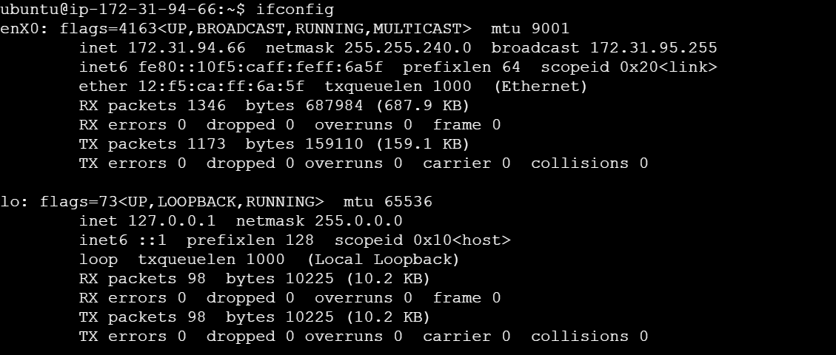

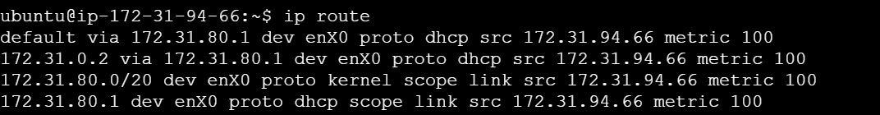

**default via 172.31.80.1 dev enX0 proto dhcp src 172.31.94.66 metric 100**

default: This is the default route — used when the destination IP is not in the routing table.

via 172.31.80.1: The gateway (next-hop router) is 172.31.80.1.

dev enX0: Traffic will go out via the enX0 interface.

proto dhcp: This route was set up via DHCP.

src 172.31.94.66: The source IP address used on this route.

metric 100: The cost of the route; lower values are preferred.

**172.31.0.2 via 172.31.80.1 dev enX0 proto dhcp src 172.31.94.66 metric 100**

This is a specific route to the IP 172.31.0.2, again routed through the same gateway 172.31.80.1 using enX0.

**172.31.80.0/20 dev enX0 proto kernel scope link src 172.31.94.66 metric 100**

This is the local subnet route.

172.31.80.0/20 means the local subnet ranges from 172.31.80.0 to 172.31.95.255.

proto kernel: Installed automatically by the kernel.

scope link: This route is valid only on the local link (no gateway needed).

Traffic to this subnet goes directly out of enX0.

**172.31.80.1 dev enX0 proto dhcp scope link src 172.31.94.66 metric 100**

Direct link to the gateway 172.31.80.1.

It’s on the same subnet, so traffic can be sent directly over enX0.

Uses enX0 as the primary interface.

Has a default gateway of 172.31.80.1.

Is in the subnet 172.31.80.0/20 (matches what was shown in the ifconfig output).

All routing is based on DHCP configuration.

Likely runs in a cloud environment (e.g., AWS EC2) where routing to internal IPs like 172.31.0.2 is common.

**Check DNS Configuration (Displays DNS servers being used.)**

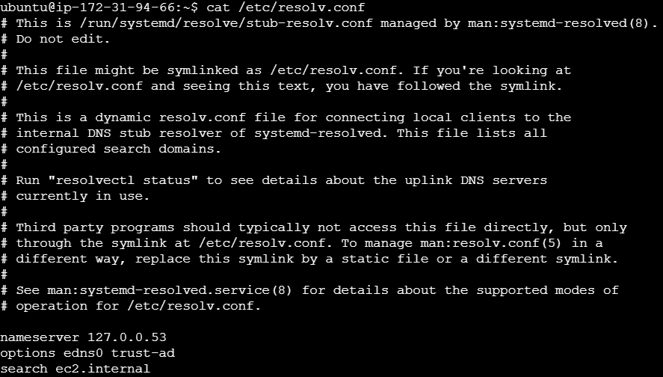

**Ping a Host (Tests if the system can reach another host)**

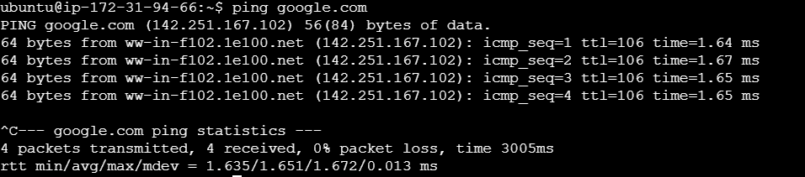

**Trace the Path to a Host (Shows the route packets take to a remote host)**

traceroute google.com

**Display Active Network Connections (Lists listening ports and services)**

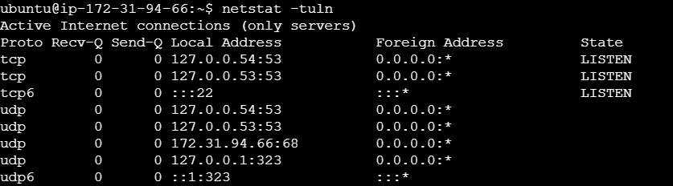

**Test DNS Resolution**

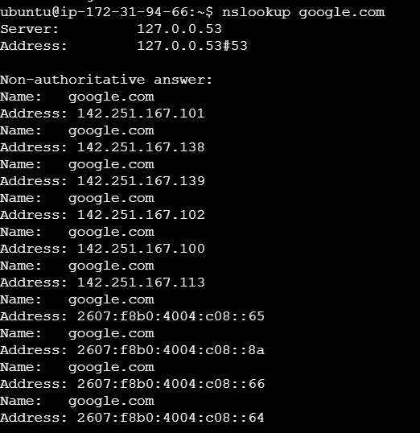

**Check Public IP(Returns your public-facing IP address)**



**Check Port Usage(Lists services listening on ports)**

